Multiple-choice section

Question 1 [5.1]

Sue has five bags of lollies, with p lollies in each bag. She eats 12 of these lollies.  
The total number of lollies that Sue has now can be written using algebra as:

A 5 + p – 12 B 5p + 12 C 5 + p + 12 D 5p – 12

Question 2 [5.1]

The sum of x and 8 is divided by 2. This can be written using algebra as:

A x + 4 B  C 8x ÷ 2 D + 8

Question 3 [5.1]

Ahmed has m marbles, Jasmine has 3 less marbles than Ahmed. Sunil has half the number of marbles that Jasmine has. How many marbles does Sunil have?

A 2m + 3 B 2(m – 3) C 2m – 3 D 

Question 4 [5.2]

Which of the following expressions has a constant term of 4?

A 5p + 4 B 4p2 C 5p – 4q D 4p + 2

Question 5 [5.2]

Which expression matches the statement below?

Choose a number and multiply it by six, subtract an other number, then add 9.

A 6m – n – 9 B 6 + m – n + 9 C 6m – n + 9 D 6m – n + 9n

Question 6 [5.6]

A like term for 7xyz is:

A 7yz B 7xy C 7xz D 5zyx

Question 7 [5.6]

Which of the following is obtained when 2p + 4 + 8p – 1 is simplified?

A 13p B 14p – 1 C 10p + 3 D 10p – 3

Question 8 [5.3]

Choose the correct algebraic rule for this sentence:

To get y, find the square root of x then add 5.

A  B  C  D 

Question 9 [5.4]

For the rule l = 7m + 1, where m = 4, l would be equal to:

A 12 B 75 C 29 D 13

Question 10 [5.4]

A rule is given as P = 4(n – 1). Which pair of values below do not fit this rule?

A n = 6, P = 20 B n = 5, P = 16 C n = 11, P = 39 D n = 12, P = 44

Question 11 [5.5]

A general rule for the following pattern is:

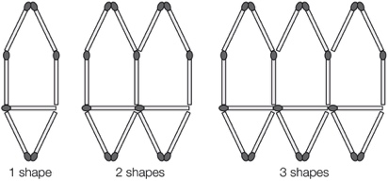

A m = 6s + 2 B m = 6s + 1 C m = 6s – 2 D m = 6s – 1

Question 12 [5.7]

Which quadrant does the point (-1, -1) lie in?

A Quadrant 3 B Quadrant 2 C Quadrant 1 D Quadrant 4

Question 13 [5.8]

What is the rule linking x and y?

|  |  |  |  |  |
| --- | --- | --- | --- | --- |
| x | 14 | 20 | 12 | 32 |
| y | 8 | 14 | 6 | 26 |

A y = x – 6 B x = y – 6 C x + y = 22 D y = 

Question 14 [5.9]

Which of the following graphs shows D and C having the same weight?

A B C D

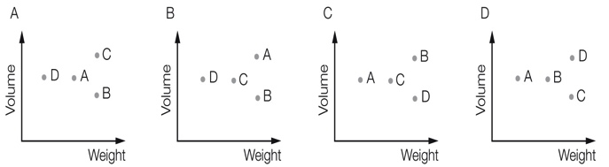

Multiple-choice total marks: \_\_\_\_ / 14

Short answer section

Question 15 3 marks [5.7, 5.8]

Use words from the list below to complete the following sentences.

x-axis formula point graph relationship y-axis quadrant

(a) The point (0, 6) is located on the \_\_\_\_\_\_\_\_\_\_\_\_\_ .

(b) The equation y = 2x + 2 is a linear \_\_\_\_\_\_\_\_\_\_\_\_\_\_\_\_\_\_\_\_ between the x and y values.

(c) The point (3, 70) is in the first\_\_\_\_\_\_\_\_\_\_\_\_\_\_\_\_ of the Cartesian plane.

Question 16 2 marks [5.2]

Define the word ‘equation’. Give an example of an equation.

Question 17 2 marks [5.1]

Write the following in simplest form using algebra.

(a) 5 is added to the product of l and p.

(b) A number is multiplied by itself then divided by 5.

Question 18 4 marks [5.1, 5.6]

Sandra has a apples. Mindy has six more apples than Sandra. Tara has twice as many apples as Sandra. Use algebra to write:

(a) the number of apples that Mindy has

(b) the number of apples that Tara has

(c) the number of apples that they have altogether. (Simplify your answer.)

Question 19 3 marks [5.1]

At a farm, there are d goats, e cows and f birds.

(a) How many legs are there on these animals altogether?

(b) If 2d + e = 10, find a set of possible values for d and e.

Question 20 2 marks [5.1]

Write an expression using algebra for the following statement:

Choose a number, square it, then choose another number and divide it by 3, then multiply the sum of the two by 2.

Question 21 3 marks [5.2]

A family ticket to a school concert costs $r and a student ticket to the concert costs $s.

(a) Define r and s.

(b) 10 students can go to the concert for the same price as three families. Write an equation for this situation.

Question 22 3 marks [5.2]

A crate of mass 2 kg contains 20 bottles. The total mass of the crate and bottles is 32 kg.

(a) Write a pronumeral to represent the mass of one bottle.

(b) Write an equation to represent the total mass of the crate.

Question 23 5 marks [5.3]

y is equal to 4 times the sum of x and 1.

(a) Draw a flowchart for this rule.

(b) Write the rule using algebra.

(c) Complete the following table of values for the rule.

|  |  |  |  |  |
| --- | --- | --- | --- | --- |
| x | 2 | 3 | 5 | 6 |
| y |  |  |  |  |

Question 24 2 marks [5.3]

The following table of values has only the y-values filled in. Use the flowchart to complete the table (remember to work backwards).

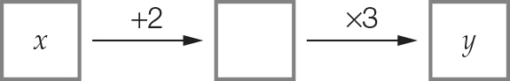

|  |  |  |  |  |
| --- | --- | --- | --- | --- |
| x |  |  |  |  |
| y | 9 | 27 | 60 | 48 |

Question 25 3 marks [5.3]

Write each of the following rules in simplest form using algebra.

(a) Subtract five from t then divide the result by three to find y.

(b) To find y, subtract m from 40.

(c) To find q, multiply p by itself then multiply the result by 4.

Question 26 2 marks [5.3]

Write the algebraic rule shown by the following flowchart.

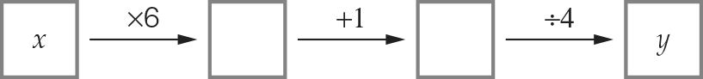

Question 27 4 marks [5.3]

Lyndall spent $70 on tools to make cards. Each card she produced cost her $5, so for one

card to be produced, it cost $70 + $5 × 1 = $75.

(a) Using this information, fill in the table below.

|  |  |  |  |  |
| --- | --- | --- | --- | --- |
| Number of cards, n | 10 | 12 | 20 | 100 |
| Cost to produce the cards, C |  |  |  |  |

(b) Write a rule for the cost of producing the cards.

Question 28 2 marks [5.4]

Answer true or false for each of the following.

(a) If you substitute a = 3 into b = 2(a + 4) then b = 14.

(b) If you substitute t = 5 into C = 7t – 20 then C = 55.

Question 29 2 marks [5.4]

Use the rule n =  to complete the table of values below.

|  |  |  |  |  |
| --- | --- | --- | --- | --- |
| m | 10 | 15 | 20 | 30 |
| n |  |  |  |  |

Question 30 2 marks [5.4]

The distance (d metres) an object will fall in t seconds can be calculated using the formula d = 5t2.

How far will the object fall in 2 seconds?

Question 31 6 marks [5.6]

Here is a matchstick pattern of shapes.

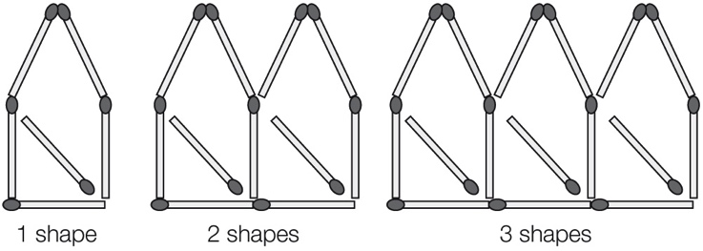

(a) Use the pattern to complete the table below.

|  |  |  |  |  |  |
| --- | --- | --- | --- | --- | --- |
| Number of shapes, S | 1 | 2 | 3 | 4 | 5 |
| Number of matches, M |  |  |  |  |  |

(b) Find a general rule that connects the number of matches to the number of shapes.

(c) Use your rule to find the number of matches needed to build 30 shapes.

Question 32 6 marks [5.6]

Simplify each expression where possible by collecting like terms.

(a) 28p – p (b) 7mn – 4nm

(c) 3a2 + 4 + 7a2 (d) 5j – 8j + 4

(e) 6p + 5q + 2p – 4q (f) 8m + 9 + 5n + m – 5

Question 33 2 marks [5.6]

Harry earns $g each week and spends $h of this amount. Write an expression to represent how much money he will have after 5 weeks.

Question 34 4 marks [5.7]

Write the coordinates of each point below.

|  |  |
| --- | --- |
| PM7_SmB_5_02scT | A \_\_\_\_\_\_\_\_\_  B \_\_\_\_\_\_\_\_\_  C \_\_\_\_\_\_\_\_\_  D \_\_\_\_\_\_\_\_\_ |

Question 35 8 marks [5.8]

(a) Plot the following points on the number plane and draw a straight line passing through all points.

(-1, 0), (0, 2), (1, 4), (2, 6)

|  |  |  |  |  |  |  |  |  |  |  |  |
| --- | --- | --- | --- | --- | --- | --- | --- | --- | --- | --- | --- |
| PM7_SmB_5_03scT | (b) Summarise the set of points in the table below.   |  |  |  |  |  | | --- | --- | --- | --- | --- | | x |  |  |  |  | | y |  |  |  |  |   (c) Write a rule linking the x and y values.  (d) Write the coordinates of another point on the line. |

Question 36 3 marks [5.9]

The point graph shows the weights and heights of an emu, a wombat and a cow.  
Write the point that represents each animal.

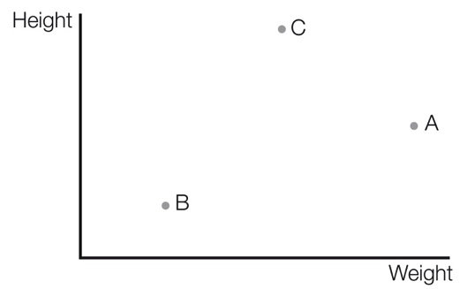

emu \_\_\_\_\_\_\_\_\_\_\_

wombat \_\_\_\_\_\_\_\_\_\_\_\_

cow \_\_\_\_\_\_\_\_\_\_\_\_\_

Question 37 6 marks [5.9]

Justin travelled by train from his suburb to the city to attend a concert. On his way home his stopped for a meal at a café, which was one train stop from the concert, before catching the express train home. This information is shown on the travel graph below.

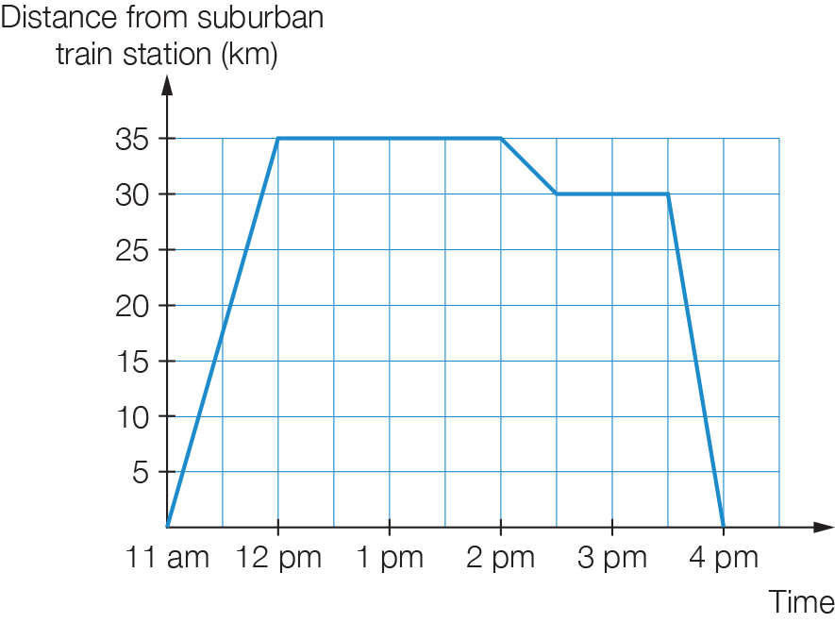

(a) How much time did the concert take?

(b) How many hours did the whole outing take?

(c) What was the total distance travelled?

(d) What speed was the express train travelling at?

Short answer total: \_\_\_\_\_\_\_\_\_ / 79

Extended answer section

Question 38 4 marks [5.2]

Paula has two jobs. The first job pays $10 per hour and the second job pays $5 per hour. Let E be the amount she earns in one week, let m be the number of hours she works at the first job in a week and let n be the number of hours she works at her second job in a week.

(a) Write an equation for the amount of money Paula earns in a week.

(b) In one week, Paula earned $100. If Paula worked at both jobs, give two possible sets of hours (whole numbers only) that she could have worked at her jobs in order to earn a total of $100.

Question 39 5 marks [5.3]

Nadine has savings for a trip. She deposits an additional $700 then uses half of her total savings to pay the airfare. Then she spends $300 on travel insurance.

(a) Draw a flowchart to show the amount she has spent (y).  
Let x be the initial amount of Nadine’s savings.

(b) Write an algebraic rule for the flowchart.

(c) Use the rule to find how much Nadine spent if she had $4100 in her savings initially.

Question 40 6 marks [5.4]

Jamie is building a timber deck. He needs 10 nails for every board and an extra 20 nails.

(a) Write a formula using algebra to represent the number of nails required. (Let b be the number of boards and n be the number of nails.)

(b) Once the boards have been laid, Jamie stains the deck. One can of stain covers 60 boards. Write a formula using algebra to represent the number of cans required.  
(Let b be the number of boards and C be the number of cans.)

(c) Use your formulas from (a) and (b) to find the number of nails and cans of stain that Jamie will need for 120 boards.

Question 41 5 marks [5.6]

I open a bank account. In the first week I deposit $x. Each week after that, I deposit $4 more than the previous week.

(a) Write an expression (in simplest form) for the amount of my fourth deposit.

(b) How much money did I deposit in the first 4 weeks altogether?

(c) How much money do I have in my account after 4 weeks if my initial deposit was $11?

Question 42 5 marks [5.8]

(a) Plot the points (3, 4) and (4, 6) on the Cartesian plane below.

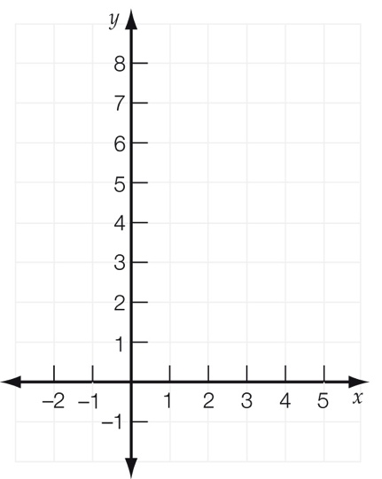

(b) Draw a straight line passing through these points.

(c) Draw a line parallel to this line, which passes through the point (1, 3).

(d) Find the value of y if (2, y) is on the line from (c).

Extended answer total: \_\_\_\_\_\_\_\_\_ / 25

TOTAL test marks: \_\_\_\_\_\_\_ / 118